**To do list strategies:**

I am so pleased to hear that you are now using to do lists, but you are right to say that they can sometimes feel overwhelming and have an undesriable effect on our wellbeing. We all feel this, not just you. As promised here are two ‘to do’ list strategies I would like us both to try this week. I hope you will join me in this experiment as we try these out and then compare. Let’s share which one we prefer (or maybe neither) in next week’s meeting. I suggest we try ‘The Matrix’ and ‘The 1,3,5 rule’ and then share our thoughts next Monday.

**Startegy 1 – The Matrix**

**The Q2 Matrix is the Key to Prioritize Projects, Tasks, and Responsibilities**

If you’ve read the [7 Habits of Highly Effective People](https://www.asianefficiency.com/likes/7-habits/), this quadrant might look familiar:

](https://www.asianefficiency.com/wp-content/uploads/2018/04/q2-matrix.png)

It is a time management system. It used to be called the Covey Quadrant, aptly named after Stephen Covey who wrote the book. Some people call it the Eisenhower Matrix popularized by president Eisenhower. It is a method to evaluate priorities and get things done in the most efficient way possible.

**Prioritizing Based on Urgency and Importance**

Here’s how it works: every item on your to-do list fits in one of the quadrants (Q1, Q2, Q3, Q4).

**Q1 – The Quadrant of Necessity**. These tasks are important and urgent. These must be done to do your work and live your life. They don’t necessarily move you forward that much towards your goals, but **not doing them** would set you back. Typical tasks are deadline-driven, time-sensitive, and part of day-to-day work and living.

**Q2 – The Quadrant of Extraordinary Productivity**. Your tasks are important but not urgent. This is where you choose what you want to work on because it gives you the highest return on your time and the tasks bring you closer to your goals. Typical tasks here are relaxation, planning, executing tasks in alignment with your goals, building relationships, and [thinking time](https://www.asianefficiency.com/podcast/162-thinking-time/).

**Q3 – The Quadrant of Distraction**. The tasks that fall in this quadrant are typically not important but *feel urgent*. I have emphasized the words “feel urgent” because this is where most people confuse what belongs in Q1 but actually do not. Typical tasks would be anything not in alignment with your goals but you somehow feel that they need to be done (false Quadrant 1 tasks). For example, attending meetings that aren’t really that important for what you do.

**Q4 – The Quadrant of Waste**. Everything here is not important and not urgent. Any tasks in this quadrant should be avoided and not done in excess. What’s interesting about this quadrant is that some activities here can belong in Q2 because they help you relax, rejuvenate, and build relationships with people. However, when done too much it’s a waste of time. Watching TV can help you relax (Q2) but done in excess is a waste of time (Q4). I love playing board games with friends (Q2) but when I go overboard for a whole evening with lots of fast food and alcoholic beverages, it becomes a Q4 activity.

Strategy 2: The 1,3,5 rule

## What is the 1-3-5 Rule?

The 1-3-5 rule is simple: in order to stay productive at work every day, you just need to commit to accomplishing **1 Major Task, 3 Medium Tasks,**and**5 Small Tasks**.

Because it covers tasks from major, medium, to small, you can be sure that you’re making progress on big projects and deliverables, down to everyday tasks, like admin work or repeating daily commitments.

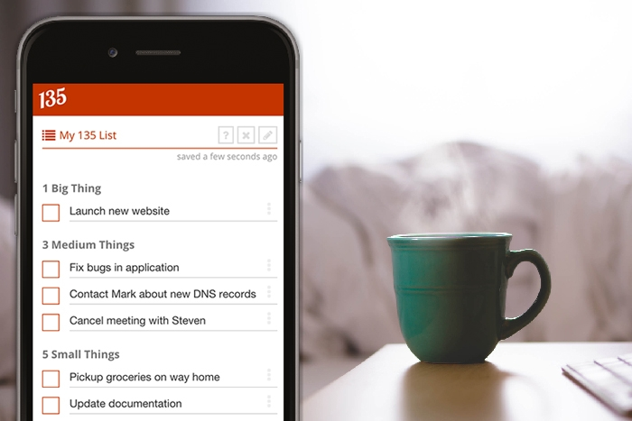  
The 1-3-5 Rule in action. Img Source: [*135list.com*](https://135list.com/)

There are several other [productivity measures](https://www.timedoctor.com/blog/work-from-home-productivity/) you can implement in your life to make sure you’re making the most of your time and energy, but this simple way of redoing our to-do lists can be a powerful tool for getting things done.

This rule cannot be more straightforward, and it’s even easier to apply. Ready to see how to incorporate the 1-3-5 rule into your own life? Here’s exactly how to get started.

## How to apply the 1-3-5 Rule

### List all your tasks for the week

At the beginning of each week, list down tasks you want to get done. These may be tasks that have spilled over from last week or are tasks you do on a regular basis.

You’ll also want to include a few urgent tasks that might come up that day, be it after a weekly team meeting or a new project or plan you’ve committed

And as you list your tasks, try to make them concrete and actionable. So recalling our friend Alex from the beginning of this post, he might put tasks like “Develop 3 new web pages for Client X” instead of “Client X deliverables.”

#### Additional tips to help implement this step:

* When you’re listing down tasks, just let everything flow out. Be okay with getting things out of your brain and onto paper. You’ll sort through it later.
* Keep a separate list for tasks to do this week versus tasks to do next week. As a general rule, whenever a new task or project comes up, jot it down immediately on your “Next Week” list.
* Doing this brain dumping exercise for all your tasks at the start of each week helps you clear out your head, giving you room to focus on one specific task at a time when it comes up – but more on that later. After all, it beats not having to worry about even remembering your to-dos. Writing them down on a list permits you to get that to-do out of your head for a while.

### Group them into Big Tasks, Medium Tasks, and Small Tasks

Once you’ve sorted out the tasks you need to do for the week, you can start to categorize them. Make columns to rearrange each task, or simply label them right beside your list.

As a rule of thumb, you can consider a task a Major Task if it takes about 3-4 hours to complete. Medium Tasks can take about 1-2. And Small Tasks may take less than 30 minutes to an hour each.

And aside from time, consider too the effort involved for each task. Some tasks might take a while but are actually quite simple and no brainer.

In this case, you might consider it a small task instead of a medium task because the effort involved isn’t great. You could probably get such tasks done sooner if you [schedule dedicated, distraction-free time for it](https://kevintpayne.com/how-much-to-spend-doing-inbound-marketing/).

#### Additional tips to help implement this step:

* Don’t become obsessed with the thought of grouping tasks perfectly. That will only waste more of your time – when in doubt, trust your gut.
* Pay attention to similar tasks and projects you’re doing and how much time they normally take you. Over time, you may realize that you overestimate and underestimate the effort involved for certain to-dos, so you can use these observations as reference for the next time you repeat this step.
* Look at the Small Tasks on your list and think for a moment if they really ought to be done by you. Can you delegate it or eliminate these tasks from your list?

### Write your to-do list

Next, you can plot out all the tasks into a daily 1-3-5 to-do list. You have the option of planning this every day – either the night before or in the morning. Or you can create a 1-3-5 to-do list for the entire week well in advance.

To avoid the lure of other tasks, use a dedicated space to write down your 1-3-5 list instead of having a long laundry list of to-dos at your desk.

If other tasks come up suddenly, you can schedule them after you’ve completed your 1-3-5 list for the day – or schedule it for the next day or week as part of your 1-3-5 list.

#### Additional tips to help implement this step:

* Use apps that are programmed specifically for the 1-3-5 list so you have a fresh page that’s ready daily.
* If you already use a specific to-do list app, there may be ways to configure it to help you implement the 1-3-5 rule. For example, creating a daily list or group (named after each day of the week) for you to put in your Big Tasks, Medium Tasks, and Small Tasks is a simple way to organize your list.
* Use a new page of your notebook or planner each day to create your 1-3-5 list. It doesn’t have to be fancy. Just commit to getting your 1-3-5 tasks on paper and zoom in on them for the day.